**Template Method**

**Intent**

Define the skeleton of an algorithm in an operation, deferring some steps to subclasses. Template Method lets subclasses redefine certain steps of an algorithm without changing the algorithm’s structure.

**Motivation**

Consider an application framework that provides Application and Document **classes**.

The **Application class** is responsible for opening existing documents stored in an external format, such as a file.

A **Document object** represents the information in a document once it’s read from the file.

Applications built with the framework can subclass Application and Document to suit specific needs. For example, a drawing application defines Draw Application and DrawDocument subclasses; a spreadsheet application defines Spreadsheet-Application and SpreadsheetDocument subclasses.

Drawing application: Spreadsheet application:

Draw Spreadsheet-Application

DrawDocument SpreadsheetDocument

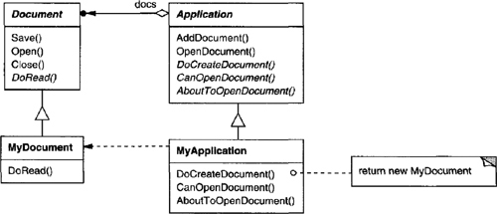

The **abstract** Application class defines the algorithm for opening and reading a document in its OpenDocument operation:

OpenDocument defines each step for opening a document. It checks if the document can be opened, creates the application-specific Document object, adds it to its set of documents, and reads the Document from a file.

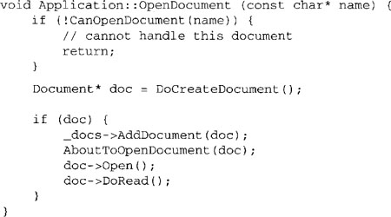

We call OpenDocument a **template method**. A **template method** defines an algorithm in terms of **abstract** operations that **subclasses override** to provide concrete behavior.

**Application subclasses** define the steps of the algorithm that check if the document can be opened (CanOpenDocument) and that create the Document (DoCreateDocument). **Document classes** define the step that reads the document (DoRead). The template method also defines an operation that lets Application subclasses know when the document is about to be opened (AboutToOpenDocument), in case they care.

By defining some of the steps of an algorithm using **abstract operations**, the **template method fixes their ordering**, but it lets Application and Document **subclasses vary those steps** to suit their needs.

**Applicability**

The Template Method pattern should be used

• to implement the invariant parts of an algorithm once and leave it up to subclasses to implement the behavior that can vary.

• **when common behavior among subclasses should be factored and localized in a common class to avoid code duplication**. This is a good example of “refactoring to generalize”. You first identify the differences in the existing code and then separate the differences into new operations. Finally, you replace the differing code with a template method that calls one of these new operations.

• to control subclasses extensions. You can define a template method that calls “hook” operations (see Consequences) at specific points, thereby permitting extensions only at those points

#### Structure

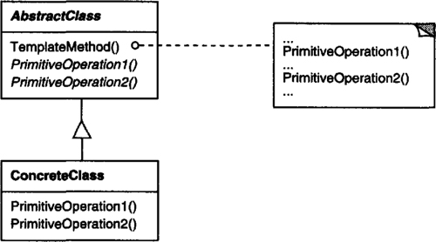

**Participants**

• **AbstractClass (Application)**

– defines abstract primitive operations that concrete subclasses define to implement steps of an algorithm.

– implements a template method defining the skeleton of an algorithm. The template method calls primitive operations as well as operations defined in AbstractClass or those of other objects.

• **ConcreteClass (MyApplication)**

– implements the primitive operations to carry out subclass-specific steps of the algorithm.

**Collaborations**

• ConcreteClass relies on AbstractClass to implement the invariant steps of the algorithm.

**Consequences**

Template methods are a fundamental technique for code reuse. They are particularly important in class libraries, because **they are the means for factoring out common behavior** in library classes.

**Template methods** lead to an **inverted control structure** that’s sometimes referred to as “the Hollywood principle,” that is, **“Don’t call us, we’ll call you”. This refers to how a parent class calls the operations of a subclass and not the other way around.**

Template methods call the following kinds of operations:

• concrete operations (either on the ConcreteClass or on client classes);

• concrete AbstractClass operations (i.e., operations that are generally useful to subclasses);

• primitive operations (i.e., abstract operations);

• factory methods;

• **hook operations**, which provide default behavior that subclasses can extend if necessary. A hook operation often does nothing by default.

It’s important for template methods to specify which operations are hooks (may be overridden) and which are abstract operations (must be overridden). To reuse an abstract class effectively, subclass writers must understand which operations are designed for overriding.

A subclass can **extend** a parent class operation’s behavior by overriding the operation and calling the parent operation explicitly:

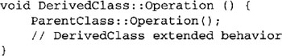

Unfortunately, it’s easy to forget to call the inherited operation. We can transform such an operation into a template method to give the parent control over how subclasses extend it. The idea is to call a hook operation from a template method in the parent class. Then subclasses can then override this hook operation:

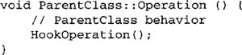

HookOperation does nothing in ParentClass:

image

Subclasses override HookOperation to **extend** its behavior:

image

**Implementation**

Three implementation issues are worth noting:

1. Using C++ access control. In C++, the primitive operations that a template method calls can be declared **protected members**. **This ensures that they are only called by the template method. Primitive operations that must be overridden are declared pure virtual**. **The template method itself should not be overridden**; therefore you can make the **template method a nonvirtual member function.**

2. Minimizing primitive operations. An important goal in designing template methods is to minimize the number of primitive operations that a subclass must override to flesh out the algorithm. **The more operations that need overriding, the more tedious things get for clients.**

3. Naming conventions. You can identify the operations that should be overridden by adding a prefix to their names. For example, the MacApp framework for Macintosh applications prefixes template method names with “Do-”: “DoCreateDocument”, “DoRead”, and so forth.

**Sample Code**

The following C++ example shows how a parent class can enforce an invariant for its subclasses. Consider a class View that supports drawing on the screen. View enforces the invariant that its subclasses can draw into a view only after it becomes the “focus,” which requires certain drawing state (for example, colors and fonts) to be set up properly.

We can use a **Display template method** to set up this state. View defines **two concrete operations, SetFocus and ResetFocus**, that set up and clean up the drawing state, respectively. View’s DoDisplay hook operation performs the actual drawing. Display calls SetFocus before DoDisplay to setup the drawing state; Display calls ResetFocus afterwards to release the drawing state.

Display template method.

Concrete operations: SetFocus and ResetFocus

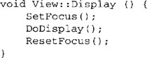

To maintain the invariant, the View’s clients always call Display, and View subclasses always override DoDisplay.

DoDisplay does nothing in View:

void View::DoDisplay () { }

**Subclasses override** it to add their specific drawing behavior:

image

**Known Uses**

Template methods are so fundamental that they can be found in almost every abstract class.

**Quiz:**

1. **How does the template method pattern promote code reuse?**

**All common code can be moved into a parent class which defines the skeleton of an algorithm**

It uses composition to wrap the common code, which can then be used in subclasses

Defines an abstraction of the algorithm, which is captured in an interface. Implementation details are then placed in derived classes.

1. **The template method fixes the order of steps in an algorithm.**

**True**

False